**Title:** To Study Open Source UX Tools (Justinmind Prototype, Pidoco, Figma, Marvel Prototype) and Create UX Design for a Given Problem Definition

**Assignment**

**Objectives**

1. To learn various UX tools.
2. To understand the features of various UX tools.
3. To select the tool which gives better functionality for the given requirement.

**Tools Used**

* **Figma**

**Q1. Compare different features of Justinmind, Marvel, and Figma tools**

| **Feature** | **Figma** | **Marvel** | **Justinmind** |
| --- | --- | --- | --- |
| **Type** | Cloud-based UI/UX design and collaboration tool | Cloud-based prototyping and collaboration tool | Desktop & cloud-based wireframing and prototyping tool |
| **Platform Support** | Web, Windows, macOS, Mobile App (Figma Mirror) | Web, iOS, Android | Windows, macOS |
| **Offline Support** | Yes (Desktop app) | Limited | Yes |
| **Collaboration** | Real-time collaboration, multiple users editing | Real-time collaboration with commenting | Supports collaboration via shared prototypes |
| **Ease of Use** | Beginner-friendly, intuitive interface | Very simple, good for quick prototypes | More advanced, requires learning curve |
| **Prototyping** | Interactive prototypes with animations and transitions | Clickable prototypes, basic animations | Highly interactive prototypes with advanced conditions |
| **Asset Management** | Components, styles, shared libraries | Limited asset management | Widgets, templates, and reusable assets |
| **Export Options** | PNG, JPG, SVG, PDF | PNG, JPG, PDF | HTML, images, documents |
| **Cost** | Free + Paid plans | Free + Paid plans | Free trial + Paid plans |
| **Learning Curve** | Low | Very low | Medium to high |

**Q2. Which of the above tool would you recommend and use and why?**

I would recommend **Figma** for the following reasons:

* **Real-time collaboration:** Multiple people can edit the design at the same time.
* **Cloud-based with offline support:** Accessible from anywhere and works offline in the desktop app.
* **Cross-platform compatibility:** Works on web browsers without installation and has desktop/mobile apps.
* **Component system:** Easy to maintain a consistent design with reusable elements.
* **Beginner-friendly interface:** Easier learning curve compared to Justinmind.
* **Integrations:** Can integrate with tools like Slack, Jira, and Notion for workflow efficiency.

**Q3. While creating your own profile design, what things did you keep in mind about the look and feel as well as other aspects?**

While designing my profile app, I considered:

1. **User-friendly layout** – Clean, easy-to-navigate pages.
2. **Visual hierarchy** – Important details like my name and photo placed at the top for immediate visibility.
3. **Consistency** – Fonts, colors, and button styles kept consistent across pages.
4. **Readability** – Sufficient contrast between text and background for accessibility.
5. **Branding** – Used colors and icons that match my personality and profile purpose.
6. **Responsive design** – Ensured it would look good on both desktop and mobile viewports.
7. **Navigation flow** – Welcome page with a clear button leading to the profile page.
8. **Aesthetic appeal** – Used proper spacing, clean typography, and relevant images.

**Q4. Screenshots of the UI created by the tool**

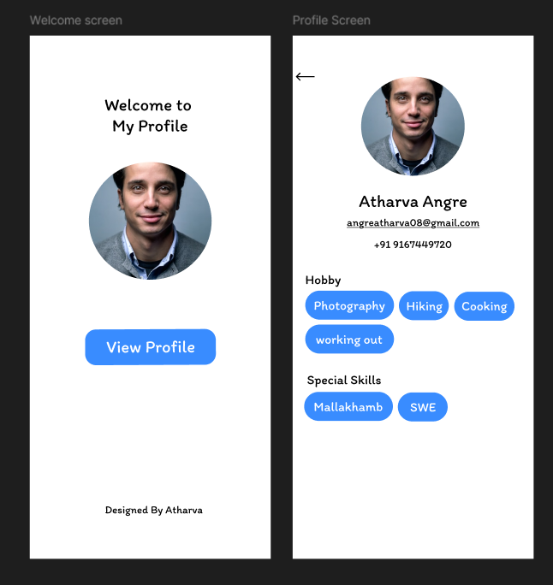

<https://www.figma.com/design/eYeDhjbgF02PvZzWOICKfb/UID-1?node-id=5-16&t=SnNJXNGZhj3TOUyU-1>